Scaffolding Pricing

A30:L66 on Item sheet – needs to go in item tab, under the elevations

Labour Extras and Extra Costs (A30:F43)

|  |  |  |  |  |  |
| --- | --- | --- | --- | --- | --- |
| **Labour extras** | **Tgt hrs** | **Qty** | **Weeks** | **Rate/wk** | **Cost** |
| Tag and HO | 0.5 | 1 | 1 |  | - |
|  |  |  |  |  | - |
|  |  |  |  |  | - |
|  |  |  |  |  | - |
|  |  |  |  |  | - |
|  |  |  |  |  | - |
| **Extra Costs** |  |  |  | **Total Extra Material Costs** | - |
|  |  | 1 | 1 | 5 | 5 |
|  |  | 2 | 22 | 4 | 176 |
|  |  |  |  |  | - |
|  |  |  |  |  | - |
|  |  |  |  |  | - |
| Total Extras | 1 |  |  |  | 181 |

**Labour Extras**

Description – free text

Target Hours – number required

Qty – number, required

Weeks – number, required

Rate per week – decimal required

Cost – calculated as weeks * qty * rate (=D31*C31*E31)

This gives Total Extra Material Cost in F37 and total extra hours in B43 (should be B37 as not related to material costs)

Same setup for **extra costs**, giving total for extras in F43

**Materials – A46:E57**

Col A is a list of names and corresponds to the materials we have already calculated in M11:S11

Qty is already calculated

Cost is qty x rate x hire period

Weight is total item x item weight

Giving total cost D57 and total weight E57

**Labour Costs H30:L50**

Lifts – take hours from lifts and x basic wage

All other materials use the same calculation

Extras – total extra hours (b43) x basic rate

Carrying – carrying hours x basic rate

Basic Hours = SUM(K30:K40)

Non production - =Basic Hours *Non_production_percentage x basic rate for cost

Supervisor - Basic Hours * **ETCW Supervision**

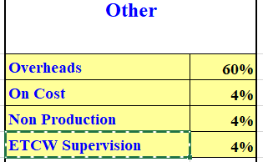

Production Labour – sums of previous columns – make header bold, it’s a heading

Indirect labour - Basic Hours x indirect labour % (sundry F10) cost = ind lab x indirect labour rate

Non productive OT – hours = production labour x NPO Hours cost = hours x Non Production OT (F4)

Days – this field needs to go somewhere else on the form, it was just put here because of spreadsheet dev.



Days = (prodn_hours (K43) / no_of_ men (summary E12)) / hours_per_day (sundry f8)

Other wage costs – no hours, just fixed number cost = production labour + indirect labour x holiday pay % (from sundry f17)

Travel – =no_of_vans (sundry tab) *no_of_days (the extra field at Item->J43) *drivers_travel_time (sundry I15)

IF(travel_time (summary j16) > threshold (sundry I16) then

Travel = travel + (travel_time-threshold)*no_of_men (summary E12) *no_of_days

Hours = travel time x travel rate

Pay related costs – header (in bold) shows totals of travel and cost = sum of other wage costs and travel

Total labour shows the sums of the sections

**Costs Summary Item H51:L66**

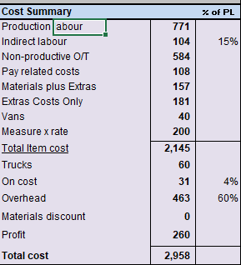

Production labour – cost from above

Indirect labour – cost from above

Non Prod OT – cost from above

Materials + Extras – from d57 and f37

Extra costs only – f43

Vans - = no_of_vans * no_of_days * vans_hire_rate / 5 +IF(distance>threshold_van,(no_of_vans*no_of_days)*((distance*2)-threshold_van) *vans_cost_per_mile) – all vars in sundry and summary

Measure Rate – Ignore

Total item cost – sum of numbers above k52:k59

Trucks – (this item weight / total weight of all items ) x truck cost (summary g59)

=IF(OR(total_weight=0,total_items_cost=0),0,total_weight/weights*trucks_cost)

On Cost – On_cost (summary g60) / total_prodn_labour * prodn_labour

Overhead Cost – (overhead_cost / total_prodn_labour) * prodn_labour

Materials Discount – This field can be renamed as Modifier % tooltip of (+ or -)

Default to 0 and error check for number between -1 and 1 (same format as other % inputs)

Show calculated number to be added or subtracted from total

Profit – profit (summary g64) / total_items_cost (sum of all items costs summary G58) * item_cost total item cost (item K60)

Total Cost - SUM(K52:K59)

**Statistics – A60:F64**

Total Cost / metre run of lift

qty = total_cost / mrol (cost E61)

cost = total_cost / SUM(lengths*lifts)

Total Cost / SqM Qty = lengths*heights cost = total_cost / D62

Total Cost / production hours = = total_cost / prodn_hours

No of fittings / production hour =

**total_fittings (N27) / (prodn_hours (K43) – sum of hours(T27) * strike_factor(G6) / (1+strike_factor))**

**Summary Page**

This is an overview total of the sum of all items (Summary A49:K65)

Use the same fields and display under items in a separate collapsible card (open by default)

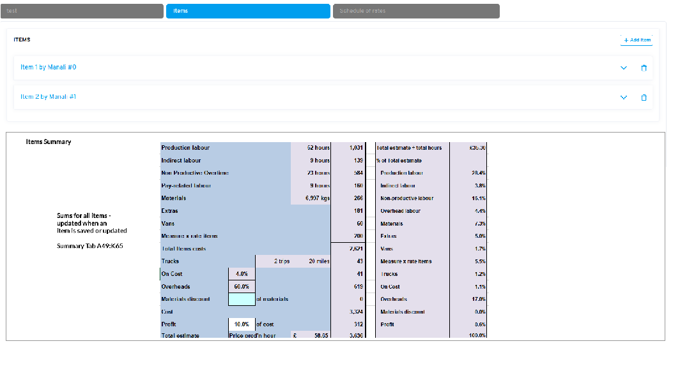

Image is for example, please use normal layout and style for the element